SUNDAY | MONDAY | TUESDAY | WEDNESDAY | THURSDAY | FRIDAY | SATURDAY
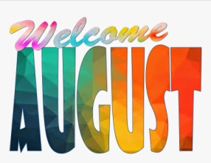 |  | 1  Walk @ Park & Slurpee  5:00-6:30pm | 2  “Anything Goes” Dinner @ OLH3  4:30-6:30pm | 3  Bingo on Zoom  6:00pm | 4  Outdoor Movie-National Lampoon’s Vacation @ New Center Park in Detroit  8:00-11:00pm | 5  Dinner & Jeff Phillips & Friends (Classic Rock, Variety, Oldies) @ Partridge Creek Mall 5:00-8:00pm  *Clients pay for own meal*
6  Belle Isle Art Fair 1:00-3:00pm  *Art, Music, Food*  Happy Birthday Kevin! | 7  Bowling @ Perfect Game  6:00-8:00pm | 8  Out to Eat  4:30-6:30p  *Clients pay for their own meal* | 9  “Anything Goes” Dinner @ OLH3  4:30-6:30pm  Hip-Prov @ Ant Hall  8:00pm | 10  Tiger’s Game 1:00pm  Groove Council (Party Band) @ Dodge Park 7:00pm  *Music, food trucks, farmers market* | 11  Lions Preseason Game @ Ford Field  7:00pm | 12  Ribs & R&B Music @ Hart Plaza  11:30am-2:00pm
13  Picnic & Paddle Boats @ Kensington Park 12:00-3:00pm  *Can walk around park if unable to do paddleboats* | 14  Bowling @ Perfect Game  6:00-8:00pm | 15  Detroit Retro Society Band @ Novi Fountain Walk  6:00-8:00pm  Happy Birthday Tom F! | 16  “Anything Goes” Dinner @ OLH3  4:30-6:30pm | 17  Magic Bus (Woodstock Era) @ Dodge Park  7:00pm  *Music, food trucks, farmers market* | 18  Joyriders (70’s Rock) @ Riley Park  7:00pm | 19  Woodward Dream Cruise  12:00-3:00pm
20  Jimmy Johns Baseball Game  1:00pm | 21  Bowling @ Perfect Game  6:00-8:00pm | 22  Cedar Point  ALL DAY!!  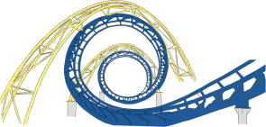  Happy Birthday Carol! | 23  “Anything Goes” Dinner @ OLH3  4:30-6:30pm | 24  Your Generation (Party Band) @ Dodge Park  7:00pm  *Music, food trucks, farmers market* | 25  Novi Taco Fest  5:00-8:00pm  *Music, food trucks, artisan market, wresting* | 26  BIA Macomb Chapter Summer Picnic  12:00-3:30pm
27  Movie Theater  Time TBD | 28  Bowling @ Perfect Game  6:00-8:00pm | 29  Bingo & Snacks @ OLH2  6:00-8:00pm | 30  “Anything Goes” Dinner @ OLH3  4:30-6:30pm | 31  Trivia Night on Zoom  6:00pm  Happy Birthday Daniel! | 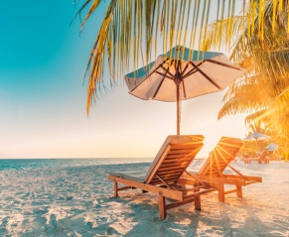 | 