SUNDAY | MONDAY | TUESDAY | WEDNESDAY | THURSDAY | FRIDAY | SATURDAY
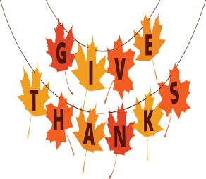 | 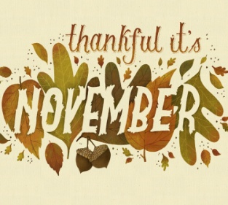 | 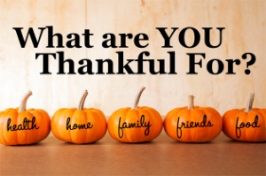 | 1  “Anything Goes” Dinner @ OLH3  4:30-6:30pm | 2  Bingo on Zoom  6:00pm | 3  Movie Theater  Time TBD | 4  Dixieland Flea Market  12:00-3:00pm  Happy Birthday John!!
5  Go Comedy! Improv in Ferndale  7:00pm | 6  Bowling @ Perfect Game  6:00-8:00pm  Bowling League 6:30pm | 7  Library  5:00-6:30pm | 8  “Anything Goes” Dinner @ OLH3  4:30-6:30pm | 9  Trivia Night on Zoom  6:00pm  Happy Birthday  Linda E!! | 10  Jersey Boys @ Birmingham Village Players 8:00pm  *Musical*  Happy Birthday Melanie!! | 11  Detroit Roller Derby @ Masonic Temple  5:00pm
12  Lunch & Outlet Shopping @  Birch Run  11:00am-3:00pm  *Clients pay for own items* | 13  Bowling @ Perfect Game  6:00-8:00pm  Bowling League 6:30pm | 14  Piston’s Game  @ LCA  7:00pm | 15  “Anything Goes” Dinner @ OLH3  4:30-6:30pm | 16  Out to Eat  4:30-6:30p  *Clients pay for their own meal* | 17  Sterling Heights Dance  6:00-9:00pm  Happy Birthday Gabby!! | 18  Hockey Game @ USA Arena in Plymouth  7:00pm  Happy Birthday Thom!!
19  Karaoke & Snacks @ OLH4  1:00-3:00pm | 20  Bowling @ Perfect Game  6:00-8:00pm  Bowling League 6:30pm | 21  Make Treats/Goody Bags for the Homeless @ OLH2  5:30-7:00pm  Happy Birthday Sarah!! | 22  “Anything Goes” Dinner @ OLH3  4:30-6:30pm | 23  Thanksgiving Dinner @ OLH3  12:00-2:30pm  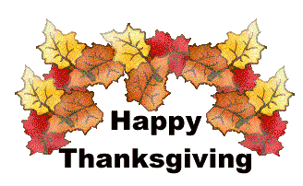 | 24  Black Friday Shopping  *Time TBD by each house* | 25  Comedy Castle  7:00pm
26  Mall Walk  1:00-2:30pm  *Times can vary* | 27  Bowling @ Perfect Game  6:00-8:00pm  Bowling League 6:30pm | 28  Bingo & Snacks @ OLH2  6:00-8:00pm | 29  “Anything Goes” Dinner @ OLH3  4:30-6:30pm | 30  Motor City Cruise Basketball Game  7:00pm | 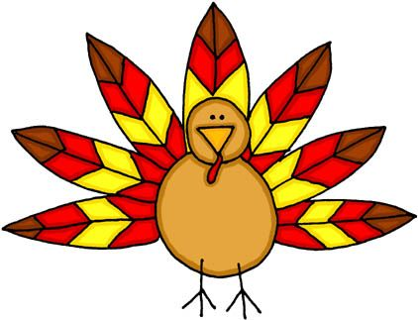 | 